HEALTHCARE ADVISORY MINUTES: Physical Therapy Assistant (PTA)
Location: Zoom
Monday January 22, 2024,
5pm-6pm

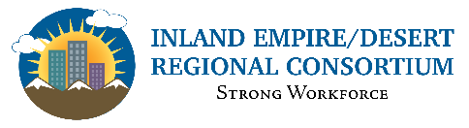

5:00 pm Welcome & Introductions: Wendy Deras, RDEE Health, Inland Empire
- Brief overview of meeting and introductions.
- The goal of the advisories is to have the information you can take back to your schools to grow more Physical Therapy Assistant (PTA) programs. I want this meeting to be informative so that you have the right information on whether or not you want to start a program. I also want you to be aware of what the industry needs are and that you have an idea of what's happening out there.

5:10 pm “Inland Empire Health Physical Therapy Assistant LMI Update” Juan Madrigal, Consultant with Center of Excellence

- Reviewed the work of the Centers of Excellence (COE).
  - The purpose is to provide quality labor market data and information to all the community colleges in the region as well as K-12 partners.
  - They assist stakeholders with program development, modifying existing programs, and pursuing new grants and meetings like this.
- Industry Data
  - In 2022 there 1.87 million jobs projected to grow by over 200,000
  - Health Care and Social Assistance was the second highest job category. This is where the PTA jobs live. There are nearly 250,000 jobs in our region in the Health Care and Social Assistance area.
  - Inland Empire desert region is expected to grow quite a bit. Nursing and residential care facilities, 12% hospitals, 11% administrative and support services, 11% and local government, 8%

- Occupational Demand
  - The path many students take on this career course. Students may start off as a physical therapist as aide, then move up to physical therapist assistants, and then to physical therapists. Below are the job opening for all three occupations and the wage information.
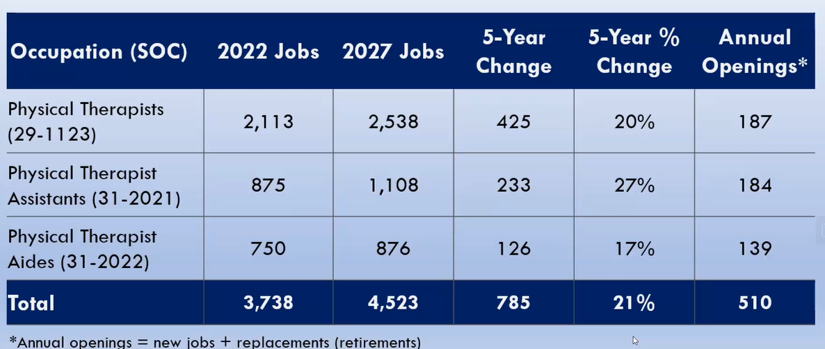
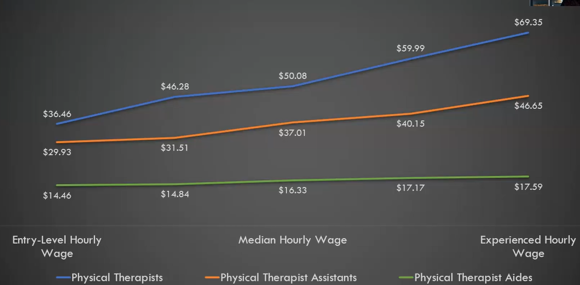
- What are employers posting in the region?
  - There were 571 job postings in the last 12 months, so January 23 to December 2023. Below is an example of the top employers and the specialized skills they were seeking, including soft skills.
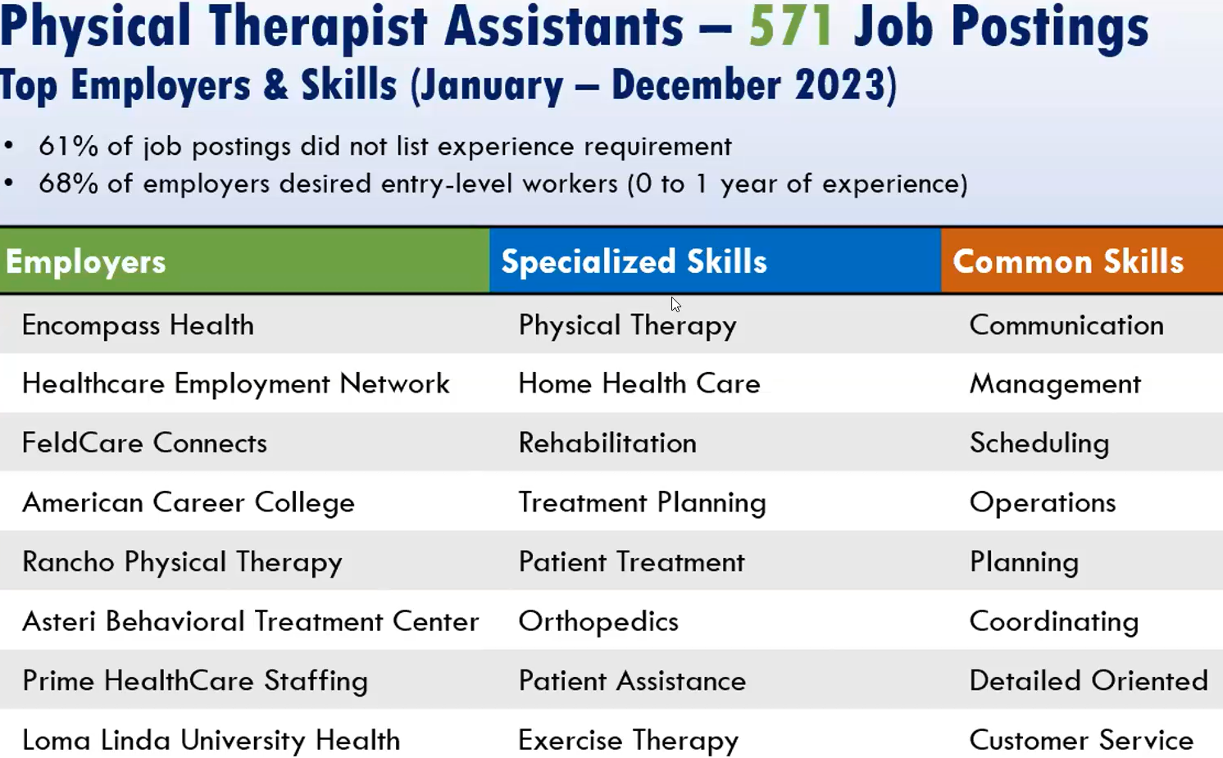

  - 61% of job postings did not list an experience requirement.
  - 68% of those re desired entry-level workers who had zero to one year of experience, which is our ideal for community colleges and our local partners can go ahead and dive into and start training.

- Educational Supply
  - There are programs, but there have not been any completions, at least any completions that have been reported to the Chancellor's office. I expanded the region to include LA/ OC, San Diego, and Imperial, and by looking at those 6 counties is data from the Chancellor's office shows that there are 4 colleges or 4 institutions that have awarded, or that have conferred awards in physical therapist assistant programs.
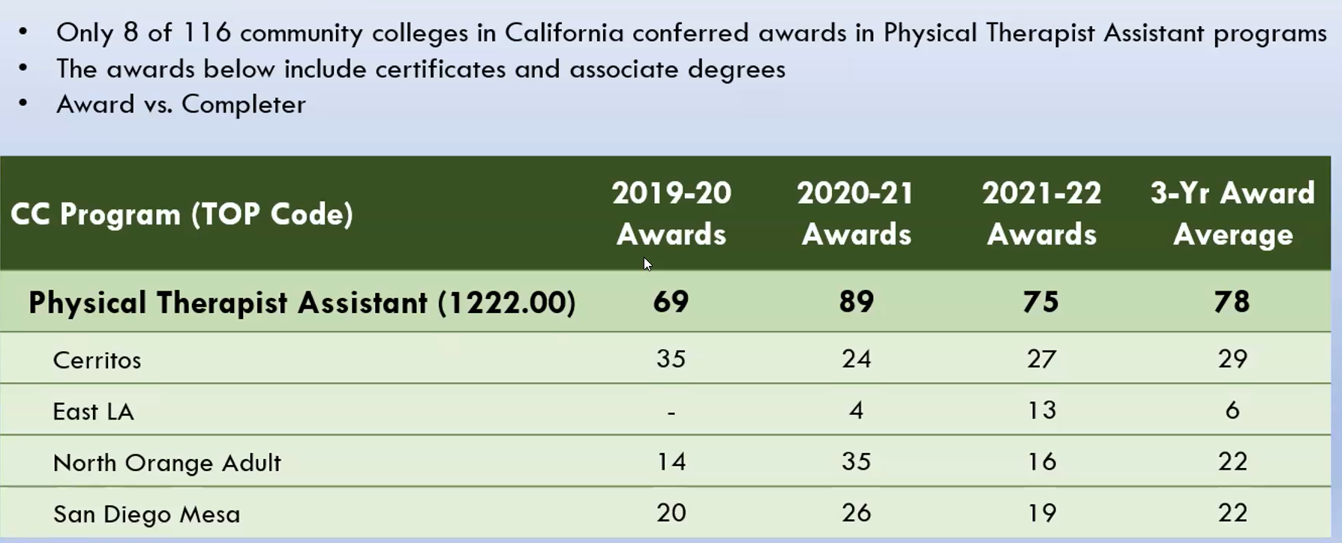
- In the Inland Empire region they have conferred awards for PTAs, which is Cal Baptist University and Loma Linda. Data below is from IPEDS.
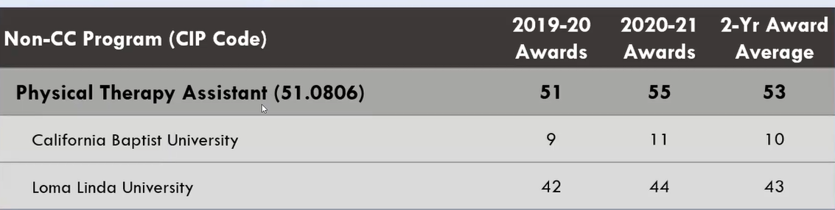

- The gap analysis, we take the annual openings. So when we take the 184, and we subtract 53 – then 131 is the estimated Labor Gap, and this is the most or the highest it could be because those 53 awards could have been 50 students. So the estimated gap will be less than that. It's always very conservative.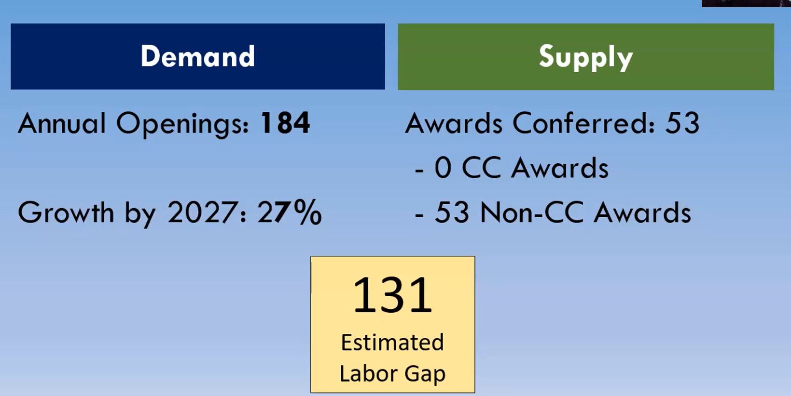
  - Shared the IE/Desert Regional Career Education Map (https://bit.ly/IECareerMap). Juan shared the how the map works and that you are able to view information on the region’s community colleges, high schools and pathways.
  - It gives you the option to drill down and find out more about industries that you're specifically interested in like Physical Therapy Assistant.

5:25 pm Program Updates:
College of the Desert: Matthew Wilson, PT, DPT
  - Program director for the physical therapist assistant program out at College of the Desert.
  - We are currently a candidate for accreditation. We just had our final onsite visit in December and should have word on the initial accreditation by the end of April or May. But at this time we are considered a candidate for accreditation which is an official credit status.

  - First cohort summer of 2023. Our curriculum is a one-plus-one model. So once a student starts with us they will be able to graduate within one year.
    - 14 students are on pace to graduate in the spring of 2024.
    - We started with 21 students. Five students were unsuccessful at progressing academically and they can re-enter the following cohort to make up that class. The five students plan to re-enter the next cohort.
    - Our program does evaluate student success in in a per class basis as well as an overall cohort, and we have identified two of our classes identified as the more challenging ones. One was our functional anatomy class and the was our neuroscience class. So we have started looking at the date to see why our students were less successful than we anticipated.

  - Second cohort – Summer 2024 and graduate in Spring 2025. Our next cohort is scheduled to start in the summer of 24. We had 44 applications for 25 seats
  - we just sent out our acceptance letters last week and have begun the official onboarding process for our next cohort of 25 students.
- Certificate program: new program. (Pre-Physical Therapist And Certificate Of Achievement)
  - Our program is developed as a one-plus-one curriculum model. So the students for that first year are completing all of their GE's and prerequisite-based classes.
  - Once they've completed all of those GE classes and prereq, they were eligible to apply to be a part of that technical phase for that last year second year of the PTA program.
  - We wanted to create a much clear path on how a student can go from starting at cod or starting at community college, then becoming an eligible applicant, we designed a certificate of achievement that we're calling the pre physical therapist and certificate of achievement.
  - This certificate is built upon all of our Prereq classes. So for a student to earn the certificate. They would have to complete all the classes that are required be eligible applicants for the PTA program. So when a student now starts at COD, they are able to declare their or they would be able to declare their major for this certificate which would automatically create an educational plan for them to complete the requirements to be able to apply to the PTA program.
  - So as our programs get larger and potentially, there is a waitlist or waiting period into the program by a student completing certificate. They can demonstrate to our community partners that they have done the class work required to get into the PTA program, showing commitment to developing and becoming either a PTA or potentially using these classes to transfer to a bachelor's degree to become a physical therapist.
  - COD is planning to do an annual basis each spring, right before Co work graduates, we will be holding an on campus job fair for all of our students. So if any employers or clinics that are interesting. Hiring a PT Assistant would like to be a part of it. Please reach out to me. Will it be a free event for you to come.
  - The question: do you support and approve the Pre-physical therapy certificate program at College of the Desert? The advisory committee supported the certificate at College of the Desert.

Chaffey College: Adeel Rizvi, PT, DPT
- Accreditation update, so as of Halloween of last year. So October 30. First, we have also been granted a candidate for accreditation status which allows us to start our first cohort, which is planned for this. May 2024 that said the application cycle is open. We hopefully want 24 students a year. However, looking at how we are also one plus one model.
- First cohort at most will have ten or twelve students.
- There was one minor change, to one textbook which is for one of our therapeutic exercise courses.
- To mitigate the effects to see if people are interested or not interested in the program. One of our prerequisites is an introduction to physical therapy course and where we kind of take everything required by certificate. I throw it in one class to kind of see where students are and what the program is all about.
- Great plans for the future. I've been in talks with Cal State, San Bernardino and we've created a couple of different partnerships with them that are on the horizon. One is a dual enrollment, like program, where their students will become knowledgeable of our program.
- The second 2 programs are bachelor's completion programs for Pt. Assistance. That will be open to both us, and we can have it open to COD students as well.
- The benefit of that is, there's 2 different track tracts. One is a degree in kinesiology with a focus on health promotion. So this is designed for individuals that want to stay as PT. Assistant but want to get more into the health and wellness arena. The second pathway that we've kind of worked on is more about health, profession, or health science.
- This requires students to then take more rigorous science courses a year of physics, you know, more biology courses, chemistry to make them eligible, for, you know, a dpt program or other health profession.
- One of the things we've also started to talk about is possibly developing a doctorate level. DPT program at Cal State, San Bernardino, as well as a possible PT Assistant. The DPT Bridge, which would be the first on the West Coast, basically the first west of Texas, which would be amazing.
- Technology update, our program has access to Physiopedia which is a professional software that has world experts kind of doing lectures. So we're going to be using that to supplement our coursework. One of the things that we're trying to do to make things objective in our program is to utilize simulation, software and equipment. For example, vital trainers that include blood pressure, heart and length sounds like devices where students can practice.
- But we're also considering, possibly purchasing a geriatric simulator and VR. We could possibly run a simulation on wound care.
- Both College of the Desert and Chaffey College had no faculty openings.

5:40 pm Moderated Industry Discussion: Moderator: Wendy Deras
Q&A to assist in developing an industry-driven curriculum in the community college PTA programs
- The advisory committee members were asked to respond to the following questions via the chat that would be fantastic.

- The first question is to the partners, are you hiring PTA's? And if so, what are your current requirements?

- What does your hiring process look like? Is it something that they find online? Or is it something a different process where they have to come in physically?
- What does your hiring process look like? And any advice that you would give an applicant like, what are you seeing if you're in the position of hiring and interviewing? What are you seeing in that process that the colleges need to be aware of. Like, if you're doing Zoom interviews, do they need some etiquette on Zoom Meetings? Are the resumes looking okay or not? Are they missing half the information in the application? They can't even be called for an interview? What is your current experience with the hiring process. And what would you tell an applicant, or what do you need to tell the colleges to be mindful of? When people apply to you.
- Are there specific interpersonal skills that you're not seeing that we need to strengthen in pro and our programs? And I know you don't have any of our graduates yet. But of the graduates you have been getting just for us to keep in mind any specific interpersonal skills that they need to be mindful of.
- Are there any weaknesses and technology or strengths you'd like to see them have that they're not coming in with? Are there new technologies in your physical therapy world that we need to consider for the curriculum?
- And the last question I'm going to combine, does your company offer internships? Experiences for our students, and if so, can you take more? And if not, can you take any? So put in the chat. If you are a partner. If you can expand, and if you'd like to be a partner, and then also put in there. If you have any job openings currently for PT. Aids or PT. Assistants.

- Comments: They don't need to move. But so there's just a lot of ways that people with neurological injuries are being overlooked, and it makes them, you know, makes them more unhealthy. They die sooner because they're just not getting the movement that they need. They're kind of ostracized from society. And they, you know, they want. There are a lot of people that want to be kind of treated like they're still human. Their recovery is really slow. because it does take a while for the nerves to regrow. Reconnect but you know, if it takes them 10 years to be able to sit up straight by themselves. Well, they eventually got there, didn't they? So that's and I think sometimes because it's such a long-term recovery mainstream says it's too long, it doesn't.
Wrap up 2025 Advisory date

